Setting Up the ZFM/ZFC on a Windows 10 DELL machine [Reference File 1.0]

Find the Link to the Setup.msi file on Dashboard ‘Knowledgebase’ for KB10826.

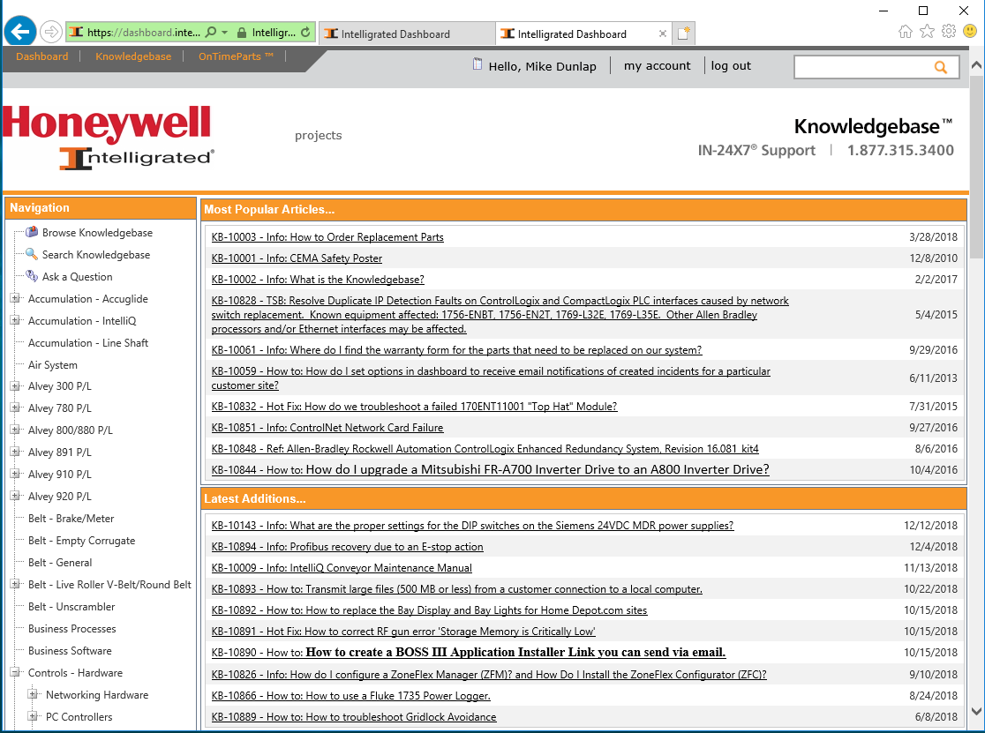

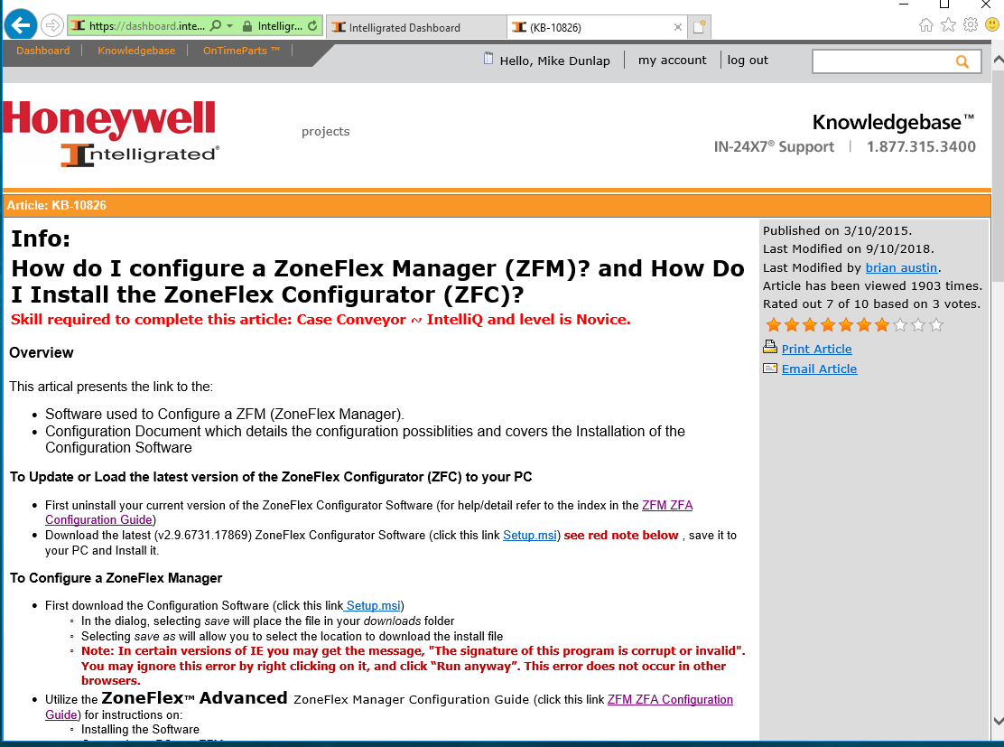

Try this Link:

<https://dashboard.intelligrated.com/Knowledgebase%20Dynamic/90f00b4b-d9dc-4fde-871f-b99b4fd50df6/Setup.msi>

The BAT File may work as well, see below.

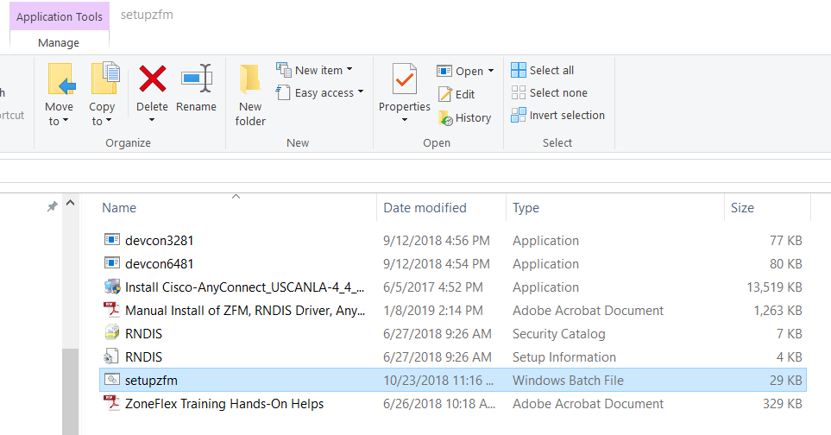

Double Click the ‘Setupzfm’ configure file

Once Done - you should get a “Loaded Successful” message [or something similar]

Verify the ZoneFlex Configurator is accessible from the Desktop (shortcut) or Start menu.

Next:

Cisco AnyConnect – we need to have Version 4.4 (or higher)

Two ways to do this:

Manual:

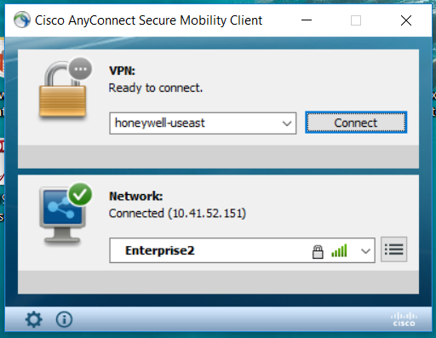

Click on the Settings Icon

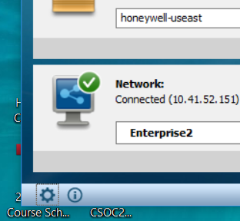

In the VPN Popup Dialog Box – Checkmark the Allow Local LAN access when using VPN

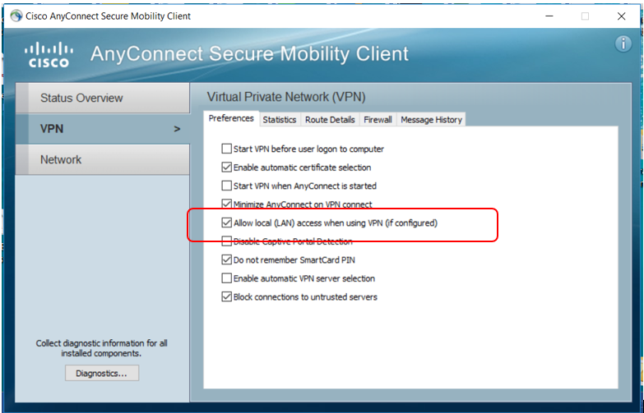

You will need to disconnect from VPN to Connect to the ZoneFlex Manager on the floor.

Run the BAT File and when prompted, plug into the ZFM.

Once plugged in you will need to go to the Settings Menu Item from the Windows Start menu

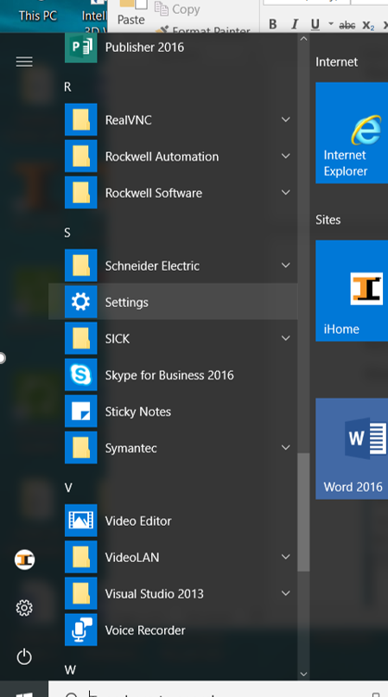

Then select Network and Internet

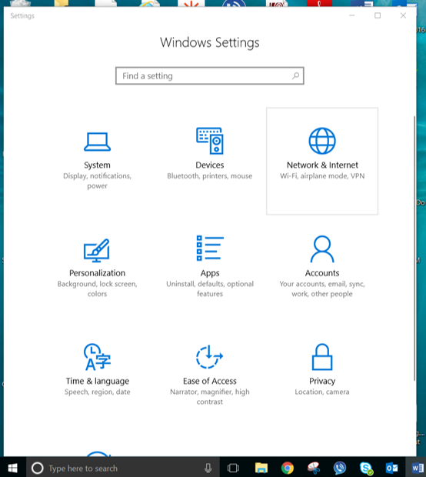

You should see a screen like the Following:

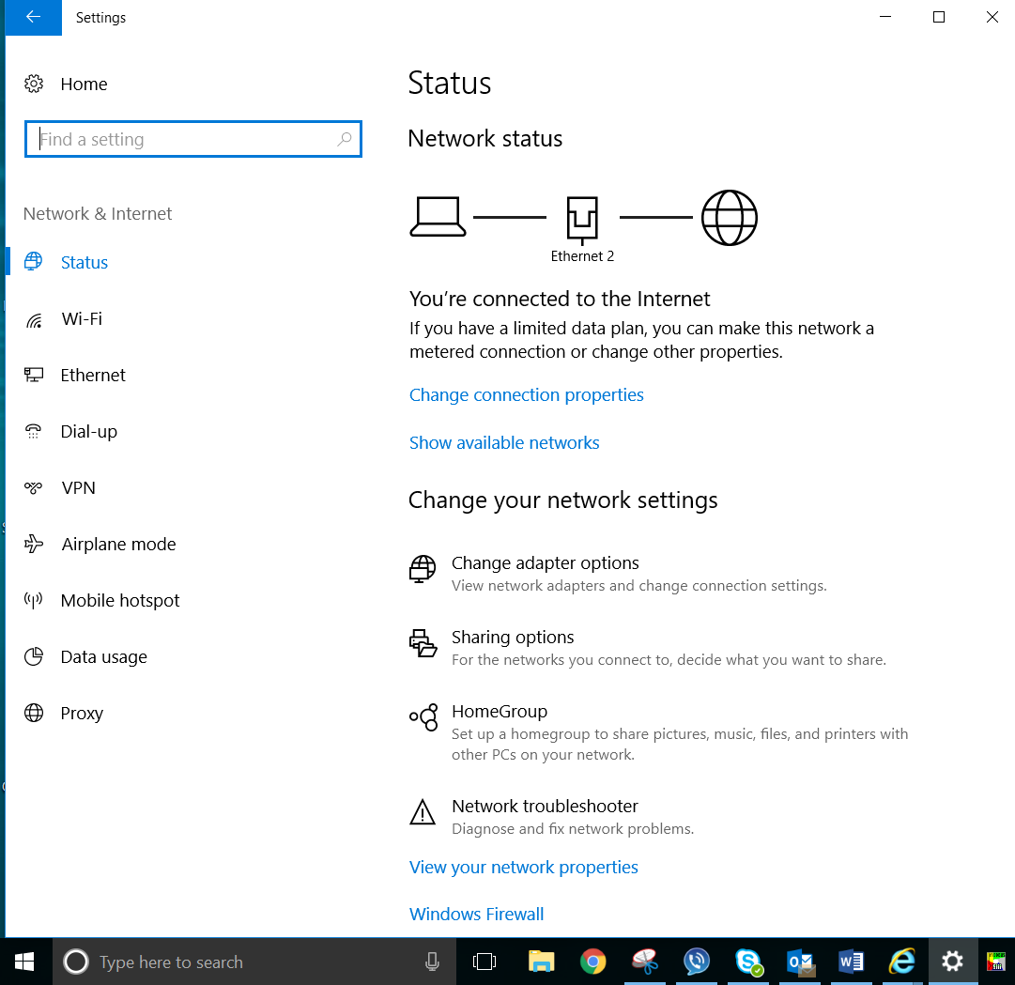

Select Change Adaptor Options:

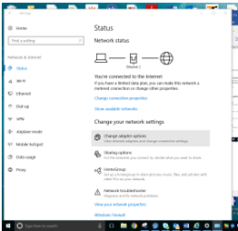

You should See Anew popup:

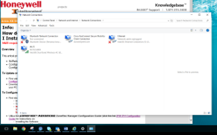

Look at the Icons. One should say Ethernet – Unidentified Device…Intel® RDNISC (Or Something like That)

Right Click on it and Select Properties

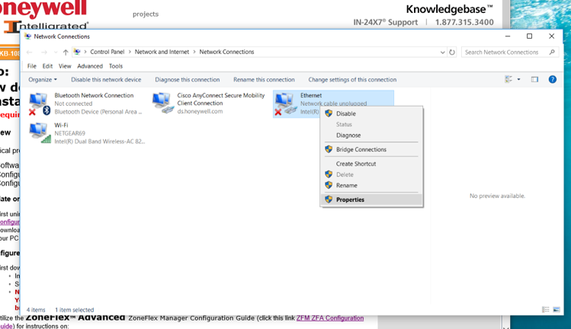

Uncheck the Cisco AnyConnect Box

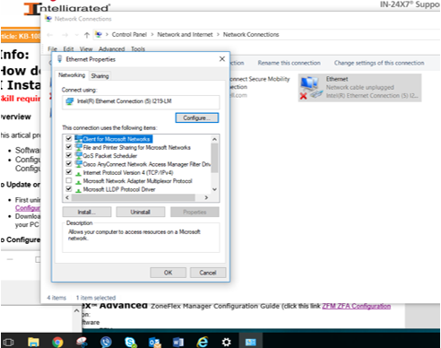

Then Select the Internet Protocol Version 4 (TCP/IPv4) line by making it highlighted, then select the ‘Properties’ button.

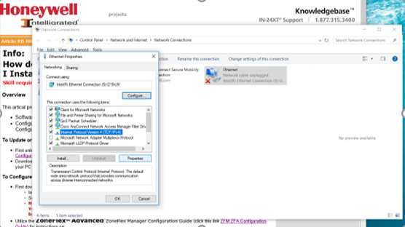

Change the Radio Button to ‘Use the Following IP address’:

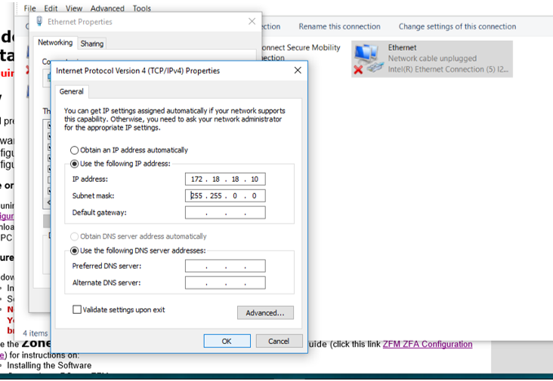

Now Run The BAT File Again, and if you get a ‘ERROR’ message try Item 2 Find ZFM

Or Connect to ZFM

If the Bat file Tests the ZFM connection it will Ping it, you should eventually see a ‘Successful’ message.

Verify that the ZFM Driver file (RNDIS) has been loaded to your Device Manager

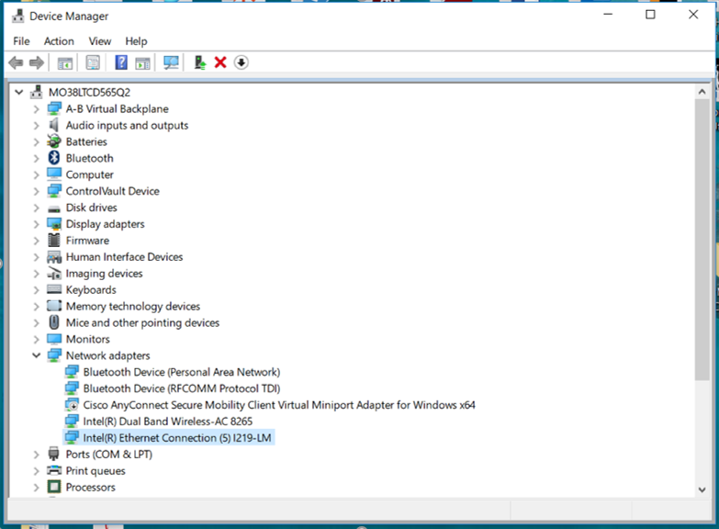

It will look a little different from the Above Example. But you should find it in your network adaptors.

When you ZoneFlex Configurator (Application on your PC) can talk to the ZoneFlex Manager (Controller on the Conveyor), you should be able to initiate the Application and Go to the Middle Menu item ZFM and select ‘ZFM Information”.

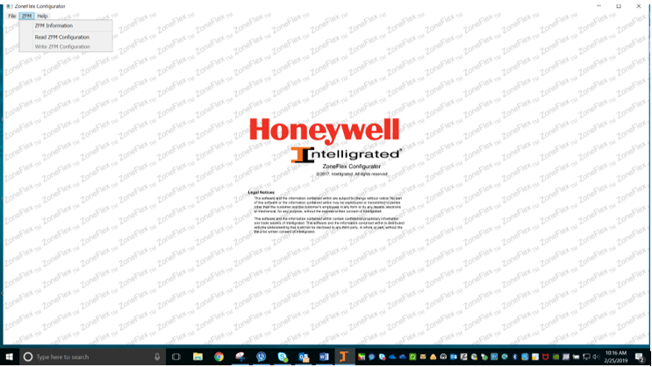

If all is well, you will see a ZFM information display screen like the following:

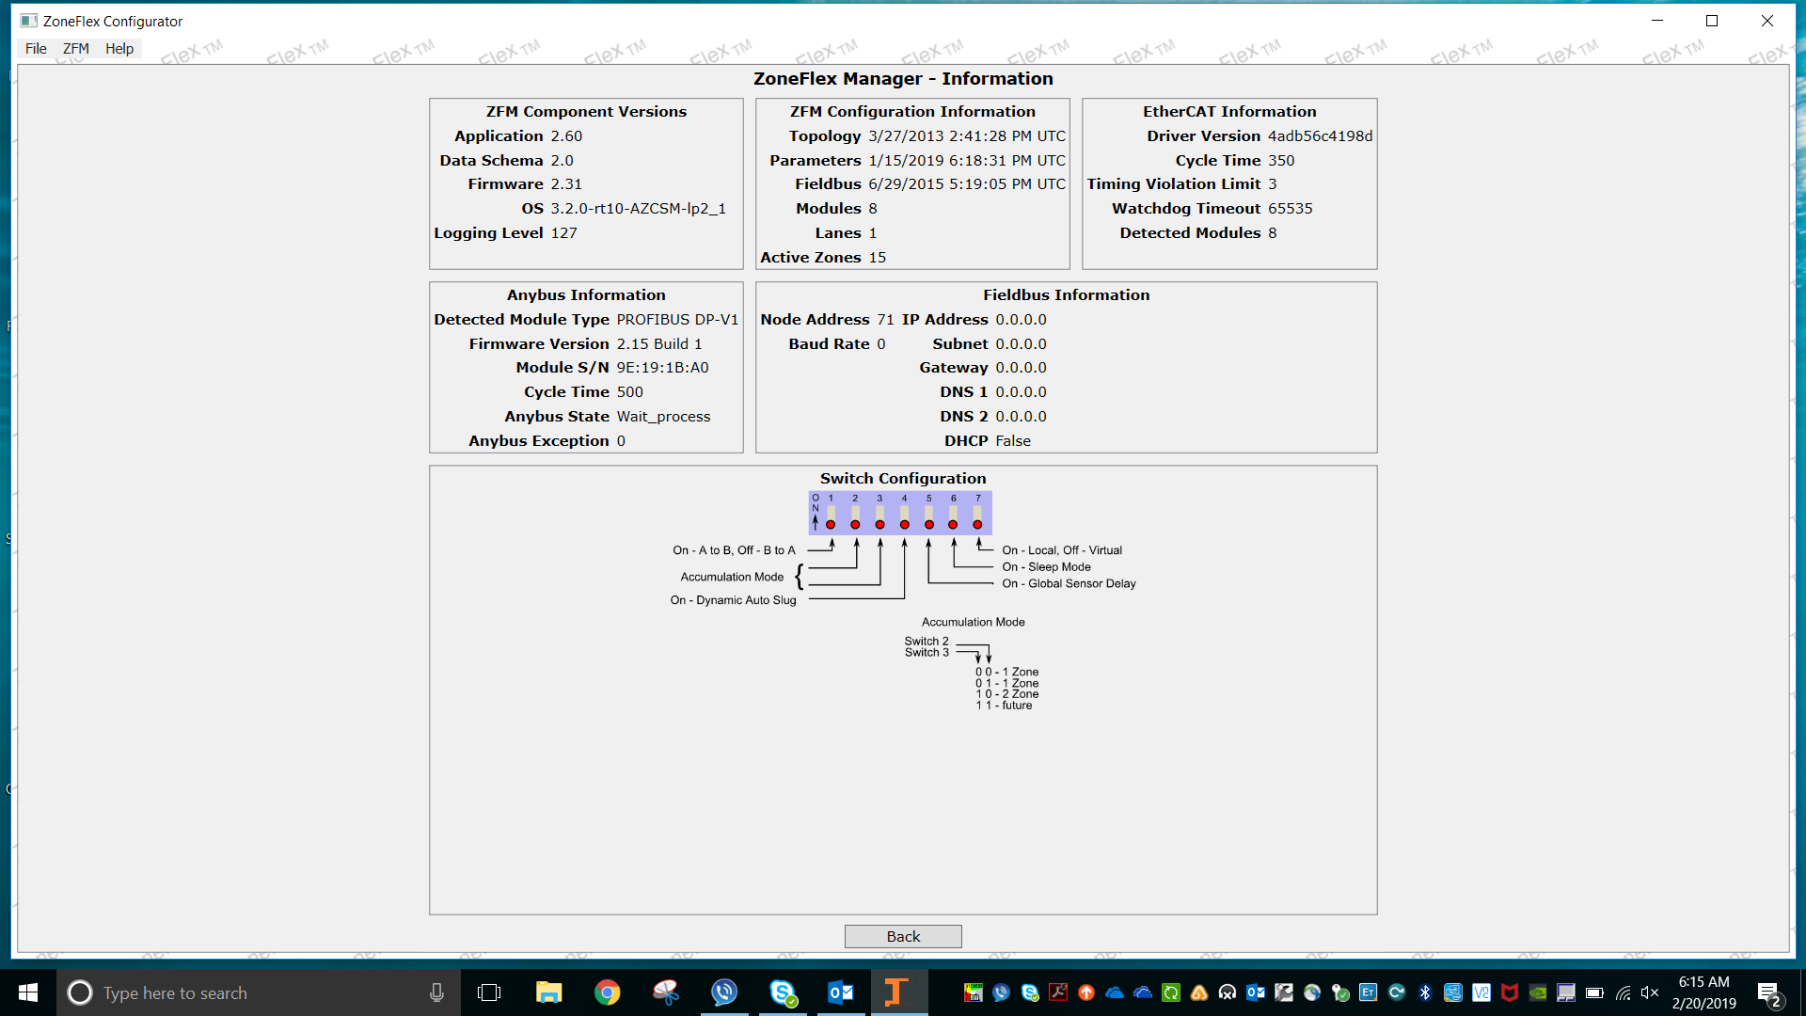

You can the select Read ZFM or Write to ZFM, depending on your task.